GuardAI — Smart Worker Safety Pole (PPE Compliance + Contactless Heat-Stress)
Technical Report — components, wiring, code, installation and use
Prepared by Ibtisam Rafiq | 13 September 2026

1. Status
Item | Detail
Current status | Starting now — design, wiring and code base complete
Progress | 15%
Platform | Raspberry Pi 5 + Camera Module 3 + thermal camera

2. Problem statement
Despite mandatory PPE regulations and heat-work-ban protocols enforced by the UAE Ministry of Human Resources and Emiratisation, worksite PPE violations and heat-related incidents remain chronically high across UAE construction and oil & gas sectors. Current monitoring relies on periodic human supervision, a reactive, inconsistent and unscalable approach that cannot detect violations in real time or assess the physiological heat burden of individual workers. Existing heat-monitoring solutions require wearable wristbands or body sensors, creating compliance, hygiene and cost challenges at scale. No commercially deployed system in the UAE integrates PPE compliance detection with contactless heat-stress assessment in a single platform.

3. System overview
GuardAI is a self-contained pole combining computer-vision PPE detection with a multi-modal heat-stress engine to produce a unified real-time Worker Safety Score. A Raspberry Pi 5 with a camera runs a fine-tuned YOLOv8 model to detect hard hat, safety vest and gloves at site entry points. An MLX90640 thermal camera captures contactless forehead skin temperature while environmental sensors compute the Wet Bulb Globe Temperature (WBGT) index. A MediaPipe pose module flags distress behaviours such as staggering, crouching or prolonged stationary posture. A weighted fusion engine classifies each worker as Safe, Caution, Danger or Stop Work. Violations and heat alerts trigger SMS to supervisors and a relay-controlled beacon, and a live dashboard provides per-check logs, daily compliance reports and trend analytics aligned to MOHRE midday-break regulations.

4. Components (bill of materials)
Component | Qty | Purpose / notes
Raspberry Pi 5 8 GB + 27 W PSU + active cooler + 64 GB SD | 1 | Runs YOLOv8n (NCNN) + MediaPipe + sensors
Camera Module 3 (wide) + 22-pin CSI cable | 1 | PPE and pose at the gate
MLX90640 thermal camera breakout | 1 | Forehead temperature, I²C 0x33
BME280 breakout | 1 | Ambient T, RH, pressure
DS18B20 waterproof + 150 mm matte-black copper globe | 1 | Globe temperature; 4.7 kΩ pull-up
2-channel opto-isolated relay module | 1 | 12 V beacon and siren
12 V beacon + siren + 12 V 3 A supply | 1 each | Alert
SIM7600 or SIM800L GSM + antenna + SIM | 1 | SMS; own 5 V 2 A supply
LEDs green/amber/red + 330 Ω | 3 | Status
IP65 enclosure, pole, sunshade | 1 | Keep Pi < 80 °C

5. Wiring
Component pins | Board pins | Notes
Camera ribbon | CAM/DISP 0 | CSI
MLX90640 VIN / GND / SDA / SCL | pins 1 / 6 / 3 / 5 | 3V3, GND, GPIO2, GPIO3
BME280 VCC / GND / SDA / SCL | pins 17 / 9 / 3 / 5 | I²C 0x76
DS18B20 VDD / GND / DATA | pins 1 / 14 / 7 | GPIO4 1-Wire
Relay VCC / GND / IN1 / IN2 | pins 2 / 20 / 11 / 13 | GPIO17 beacon, GPIO27 siren
GSM TXD / RXD / GND | pins 10 / 8 / 25 | GPIO15 RX, GPIO14 TX
LEDs G / A / R / cathodes | pins 15 / 16 / 18 / 30 | GPIO22/23/24
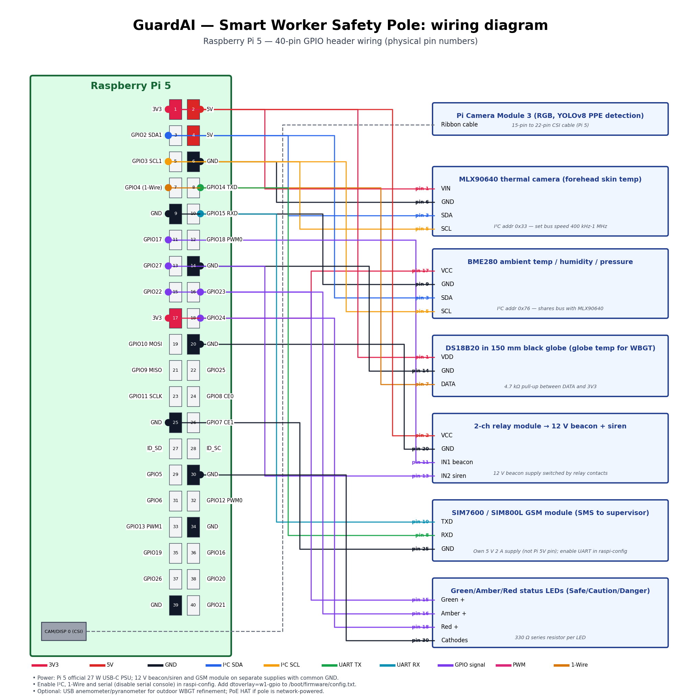
Figure 1 — guardai_wiring_diagram.png

6. Software structure
code/guardai/main.py orchestrator loop + dashboard thread
code/guardai/vision/ camera.py, ppe_detector.py (YOLOv8), pose_monitor.py (MediaPipe)
code/guardai/sensors/ thermal.py (MLX90640), environment.py (BME280 + DS18B20), wbgt.py (ISO 7243)
code/guardai/fusion/safety_score.py weighted score → SAFE / CAUTION / DANGER / STOP WORK
code/guardai/alerts/ sms.py (AT commands), beacon.py (relays + LEDs)
code/guardai/dashboard/ server.py, templates, static
code/config/settings.yaml thresholds, pins, weights, MOHRE midday-break window
code/scripts/ setup_pi.sh, train_ppe.py, calibrate_thermal.py
code/systemd/guardai.service
code/tests/test_wbgt_and_fusion.py (3 tests passing)

7. How it works
- Each cycle (5 fps) the camera frame goes to the YOLOv8 PPE detector and to MediaPipe pose (stagger, crouch, stationary).
- The thermal camera reports the mean of the six hottest pixels as forehead skin temperature; BME280 and the black-globe DS18B20 give ambient T, RH and globe T.
- WBGT = 0.7·Tw + 0.2·Tg + 0.1·Ta with Tw from the Stull approximation; thresholds 28 / 30 / 32 °C.
- heat_score = max(environmental, body); ppe_score = 0.4 per missing item; posture_score from pose flags. Score = 0.35·PPE + 0.45·heat + 0.20·posture; STOP WORK is forced when heat = 1.
- The state drives LEDs, beacon (DANGER/STOP) and siren (STOP); DANGER/STOP sends an SMS per supervisor with a 5-minute cooldown.
- Every check is written to SQLite; the dashboard on port 8080 shows live state, recent events and the daily compliance report.

8. Installation
bash code/scripts/setup_pi.sh # apt packages, I²C / 1-Wire / UART, venv, requirements
sudo reboot
i2cdetect -y 1 # expect 0x33 (MLX90640) and 0x76 (BME280)
python code/scripts/train_ppe.py # on a laptop/Colab with a PPE dataset -> copy best.pt to code/models/ppe_yolov8n.pt
python code/scripts/calibrate_thermal.py # set thermal.forehead_offset_c
sudo cp code/systemd/guardai.service /etc/systemd/system && sudo systemctl enable --now guardai

9. How to use
- Workers pause at the marked spot 1–1.5 m from the pole facing the camera.
- LEDs show the state; beacon/siren fire on DANGER/STOP WORK; supervisors receive SMS.
- Open http://<pi-ip>:8080 for the live dashboard and /api/report/today for the daily report.
- Edit config/settings.yaml to change thresholds, supervisor numbers, fusion weights or pins; restart the service.

10. How to connect
- Enable I²C, 1-Wire and serial (console disabled) in raspi-config; add dtparam=i2c_arm_baudrate=400000.
- GSM module on its own 5 V 2 A supply with common ground; SIM with SMS enabled.
- 12 V beacon/siren switched by the relay contacts; never through the Pi.

11. Acceptance tests
- PPE detector ≥ 90 % mAP@0.5 and ≤ 300 ms per frame
- Thermal within ±0.5 °C of a clinical thermometer after calibration
- WBGT within ±1 °C of a commercial meter
- STOP WORK raised within 3 s of a simulated 33 °C input; SMS received
- Daily report totals match the database

12. Next steps
- Order the hardware (3–4 weeks lead time) and run setup_pi.sh.
- Collect and annotate ~1,500 PPE images (Roboflow) and train YOLOv8n; export NCNN for the Pi.
- Bring up sensors one at a time (thermal, BME280, globe) and verify WBGT against a reference meter.
- Integrate pose and fusion; confirm the three unit tests still pass with real readings.
- Assemble the pole and enclosure; run a shaded outdoor trial at the school gate; calibrate thermal on 10 subjects.
- Prepare the final report and presentation from the dashboard logs.

13. Handover items
- Design pack (this document), wiring diagram, code base and tests
- No hardware purchased yet

Appendix — low-cost variant
Low-cost variant: replace the Pi 5 + Camera Module 3 (≈ AED 620) with an ESP32-S3 camera board (XIAO ESP32S3 Sense / ESP32-S3-EYE, ≈ AED 60–120) running a TinyML classifier trained on Edge Impulse for hard hat and vest only; replace the MLX90640 (≈ AED 300) with an MLX90614 single-point IR sensor (≈ AED 40) read at 30–50 cm; drop the pose module and send alerts through Wi-Fi (Telegram/WhatsApp) instead of a GSM module. Total ≈ AED 250–350. The WBGT, fusion and alert logic in this pack is platform-independent and carries over; the abstract must be amended to say “lightweight on-device neural network for hard-hat and vest detection”.

Prepared by Ibtisam Rafiq, 13 September 2026.

